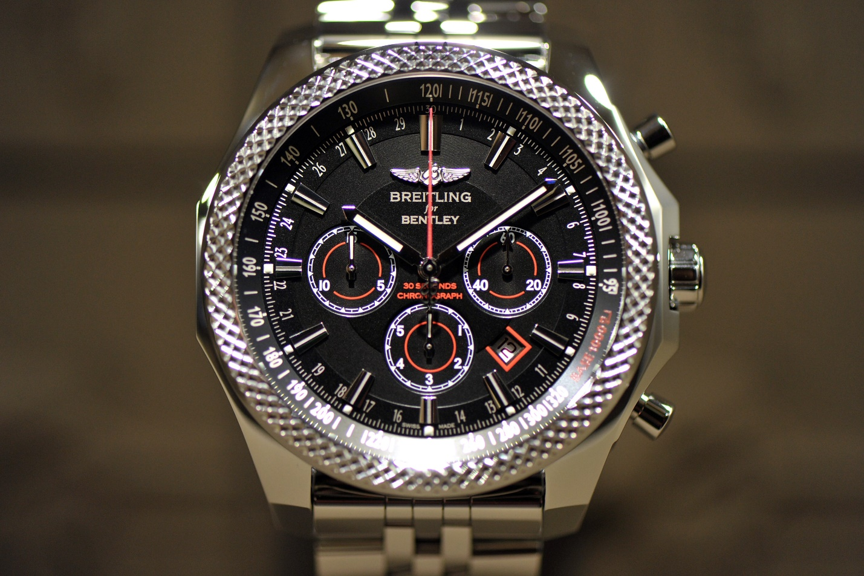Description: Breitling is a prestigious Swiss luxury watch brand known for its precision, craftsmanship, and connection to aviation. Founded in 1884, Breitling has established itself as a leader in creating high-performance timepieces, particularly for pilots and professionals in the aviation industry. Their watches are renowned for their **chronograph movements**, **aviation-inspired designs**, and **rugged functionality**. Breitling's signature features include **large, easy-to-read dials**, **rotating bezels**, and **superior water resistance**, making them ideal for extreme environments. Iconic models like the **Navitimer** and **Superocean** are recognized worldwide for their reliability and technical excellence. With a reputation for combining style, precision, and innovative technology, Breitling watches are highly sought after by collectors and those who appreciate luxury and performance.